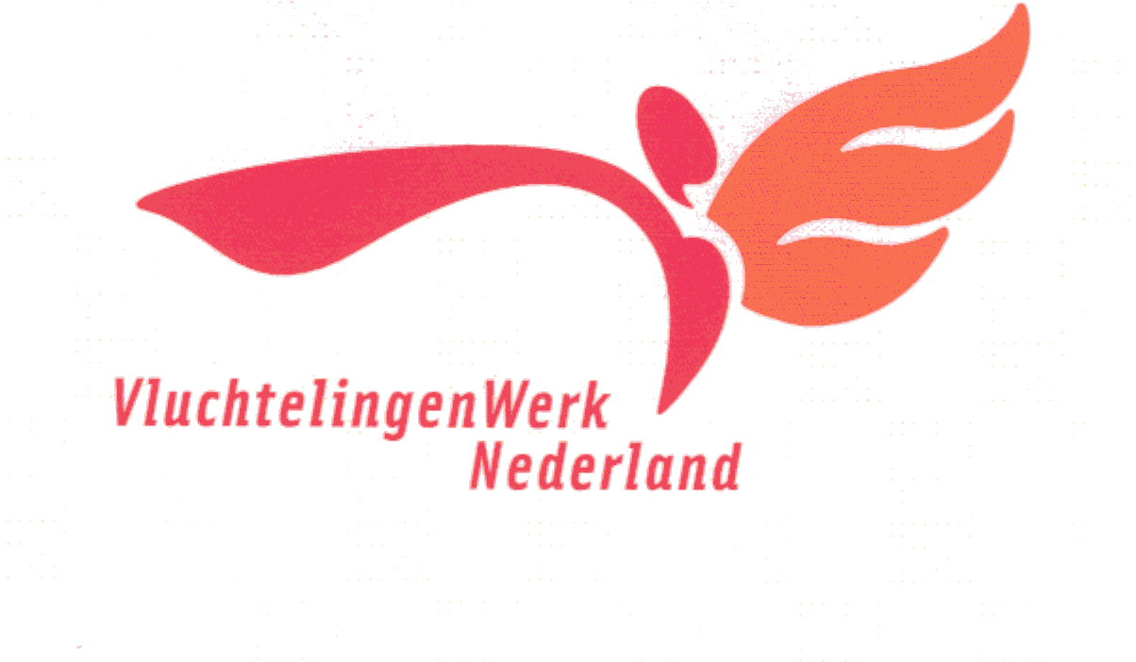**REFUGEE WORK SOUTHWEST NETHERLANDS**

**C22: Accompanying Agreement**

Stichting Vluchtelingen Werk Zuidwest Nederland provides social guidance for refugees and asylum seekers. The aim of this guide is to promote the client's self-reliance and integration into Dutch society. Refugee work in the southwest of the Netherlands initially works with both professionals as volunteers

The undersigned:

Foundation for Refugees Southwest Netherlands,

represented by: function:

and the client:

Name (full) :................................................. ......................

Address: :................................................ ..................................................

Date of birth:................................................ ..................................................

agree to the following:

**Generally:**

1- Social counselling provides 4 services:

-Training Institution: Guidance towards making a good start to further integration by achieving suitable accommodation, suitable facilities and services, and registration with various jobs. This stage ends with a closing conversation

- Integration of training: (next to the training institution) with decision-making processes in the Netherlands to fulfil the wishes. Inform the client of the client's terms in relation to these operations.

- Information point: provides an hour of open consultation for questions and information

-Accommodation control informing the client of the consequences of (possible) changes in the client’s residence status; Informing the client of the administrative procedures related to family reunification procedures.

2- For the above services, a contact of the client is appointed as a social counsellor, and he can go to the office for this purpose, or contact an employee who specializes in a particular field.

3- For proper workflow, the client and the employee of the Refugee Council shall abide by the agreements concluded between them.

4- The client remains responsible for the decisions and behaviour during the consultation process.

5- Refugee work staff in the southwest of the Netherlands working on issues of policy and responsibility in the southwest of the Netherlands do not receive any financial reward for their work, neither from refugee work in the southwest of the Netherlands nor from the client. They already receive an expense allowance from VluchtelingenWerk Zuidwest Nederland for costs incurred.

Advice on housing and home furnishing. Introducing the place of residence and instructing the authorities, institutions and shops; Support in the organization of financial affairs; Information about the place of residence and the procedure for family reunification; Information and advice regarding health care, educational issues, voluntary work, paid work and other forms of participation in Dutch society. Volunteering, paid work and other forms of participation in Dutch society.

**File configuration:**

6- The Refugee Council of the Southwest Netherlands creates a client profile in order to promote the achievement of the goals of the counselling process. For this purpose, the data is also recorded in the VVS (Refugee Tracking System). The customer has the right to view his private file. At the end of the supervision period, agreements are concluded on the return of the file documents.

-7 The client agrees, for the client's best interest, to hand over copies of the documents and documents from his file to the lawyer or the Dutch Refugee Council. Each time the customer is informed of this by phone or orally. If, for the benefit of the customer, the information from the file is transferred to other persons or bodies involved in immediate assistance, the prior consent of the customer is required. In some cases, written permission is required.

**End of agreement:**

8- In principle, this supervision agreement expires two years after the signing. The training ends with a closing conversation. If guidance is still required on certain points, then agreements regarding the content and duration of these Guidelines will be recorded. With mutual consultation, supervision can be completed early. The customer has the right to terminate the agreement prematurely.

9. The Agreement may be prematurely terminated by the Refugee Council when.

-a way of working together makes good supervision impossible.

b The client engages in socially illegal activities.

-c The client appears to have committed a human rights violation.

-d The client puts the work of the Refugee Council in a bad light.

**Complaints Procedure:**

10. If the client has a complaint about a refugee council employee, he can request to meet with that employee or his manager. After this conversation, the next steps are outlined. If this does not lead to a satisfactory solution, the customer can turn to the complaints committee.

**Agreement (consisting of two copies):**

Stichting VluchtelingenWerk Zuidwest Nederland

Location: Location:

date: date:

Name: Name:

Signature: Signature:

Each adult family member must co-sign!