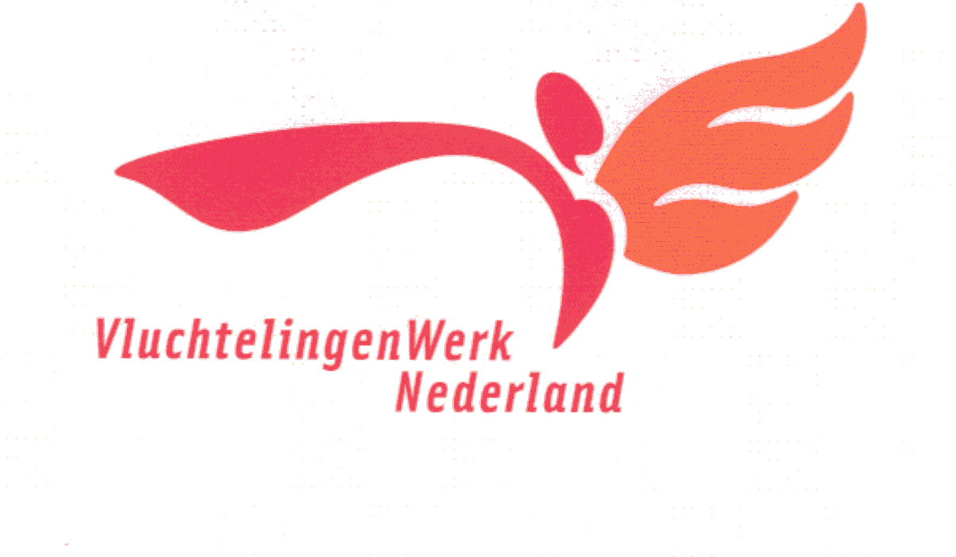 **Mandate 1 – Juridical procedure**

I hereby give:

**First and last name:** Al-Hemyari, Abdualmajed Dabwan Mohammed

**V - Number**: 2901958172

**Date of Birth**: 04-03-1981.

Employees of the Dutch Council for Refugees and regional refugee institutions have the right to:

* the joint management of public and private personal data that you have provided that are necessary for legal action in a national digital (electronic) file system;

* Process my legal identification number such as a Citizen Service Number (BSN) and V number only on my behalf and on my behalf to the extent that I am legally required to use this identification number to communicate with organizations that have a legal basis for it. The Refugee Council does not explicitly treat my identification number as a controller within the meaning of the privacy regulations, but as a processor;

* If I move ( as a result of a move) between regional refugee employment organizations to make my digital file available to employees of the regional refugee employment organization to which I have moved;

* To be able to view, change, and complete my profile in multiple areas at the same time only as often as necessary to guide me in legal proceedings.

All my data will be treated confidentially and will only be used for the purposes for which it has been notified to me. These goals are guidelines while:

- Asylum procedures at refugee reception centers in the Netherlands, and/or

- The normal procedure in refugee reception centers in the Netherlands.

-Family reunification procedure.

- Participation in return activities.

My data can also be used for policy development within the Refugee Council. In addition, I will be notified by VluchtelingenWerk of the new targets. I also give permission to process and use the data of my children under the age of 16 in the manner described above.

**Location:** Noordwijk

**Date:**

**The name:**

**Signature:**

**Information about your data usage:**

What is the work of refugees?

The Dutch Refugee Council is an independent organization that advocates for the rights of refugees and helps them build a new life in the Netherlands. The Refugee Board assists asylum seekers with their asylum procedure, civil integration, and other questions asked by asylum seekers. The Dutch Refugee Council is made up of a national association and the regional institutions of Northern Holland, Eastern Netherlands, Western and Central Netherlands, southwestern Netherlands and southern Netherlands.

Personal Data Protection Law:

In the Netherlands there is legislation that protects your privacy. The Personal Data Protection Act (Wbp) regulates how the Refugee Board handles your personal data. This law states that this must be done carefully and in a safe manner. Any person whose data is registered has the right to monitor the proper use of it. You can, for example, always view, correct, supplement, delete, protect or transfer your private data.

Your personal data:

To provide you, for example, with general data such as your name, address, nationality, date of birth, data about your asylum procedure and your personal circumstances. Information about your personal circumstances may contain private personal information. This data is considered very sensitive in the Netherlands and needs to be handled more carefully. This may include statements about, for example, your race, health, religion, belief or political affiliation. Wbp prohibits the use of private personal data unless required by law or if you have given us your express consent. Your personal data is recorded if this is necessary for your asylum procedure.

Permission:

In order to be able to help, VluchtelingenWerk needs personal data from you. This is permission only so that we can guide you, we ask for your written permission to use your data and allow you to store it in our automated file system. If you move to another reception location, the Refugee Council will send the file to the Refugee Council at the next reception location, so that guidance can continue (during the asylum procedure or during integration). The Refugee Council obliges all its employees to observe confidentiality and to treat your data confidentially.

If you are not satisfied with the way VluchtelingenWerk handles your personal data, you can file a complaint. The regulations that state how to file your complaint are available for inspection at the Refugee Board. You can always ask about this.

Do you want more information?

How VluchtelingenWerk treats your data is described in a set of regulations. If it seems a little complicated to you and if you have any questions as a result of the information, please feel free to contact us. We are here to help and inform you as best we can.

Sincerely ,

**Refugee organization in the Netherlands**