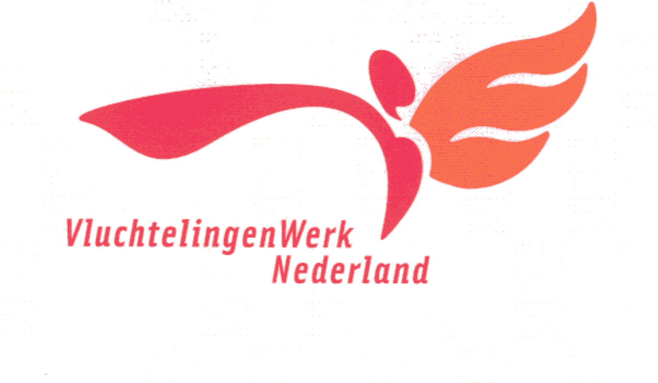 **Mandate 2 - Social Counselling**

I hereby give:

**First and last name:** Al-Hemyari, Abdualmajed Dabwan Mohammed

**V - Number**: 2901958172

**Date of Birth**: 04-03-1981.

**Permission for the staff of the refugee organization:**

-management of public and personal personal data necessary for the purposes listed below to be managed in a national digital filing system;

- To process my identification number by law and my identification number, such as a citizen service number, only names and on behalf of me in so far as I am the basic requirements to work in contact organizations.

Does not expressly treat my identification number as a controller within the meaning of the privacy regulations, but as a processor.

All my data will be treated confidentially and will only be used for the purposes for which it has been notified to me.

**These goals are guidance:**

- In housing.

-In social counseling for education and work.

- In the case of legal proceedings outside asylum seekers centers (for example, if your residence permit has expired.

My data can also be used for policy development at VIluchtelingenWerk. In addition, I will be notified by the Dutch Refugee Council about the new targets. This mandate applies to the National Refugee Association and to:

O Foundation for Refugees North Netherlands

O Foundation for Refugees East Netherlands

O Foundation for Refugees West and Central Netherlands

O Foundation for Refugees South West Netherlands O Foundation for Refugees South Netherlands

**City:**

**Date:**

**The name:**

**Signature:**

Information about your data usage:

**What is a refugee council?**

1- Just mark one organization here If you move to another organization, you have a second signature that is placed with a new date two months later the signature of consent as the basis for processing Automatically ends identification of the personal data of the previous organization unless you indicate that your permission will continue to apply. However, it is also possible that the previous organization will continue to process your data on a different basis, such as to comply with a legal regulation or to implement an agreement to which you are a party or a legitimate interest.

2- For persons under 16 years of age, the legal representative must state and sign his name.

**Dutch refugee organization:**

It is an independent organization that advocates for the rights of refugees and helps them build a new life in the Netherlands. The Refugee Board assists asylum seekers with their asylum procedure, civil integration, and other questions asked by asylum seekers. The Dutch Refugee Council is made up of a national association and the regional institutions of Northern Holland, Eastern Netherlands, Western and Central Netherlands, southwestern Netherlands and southern Netherlands.

**Personal Data Protection Law:**

In the Netherlands there is legislation that protects your privacy. The Personal Data Protection Act (Wbp) regulates how the Refugee Board handles your personal data. This law states that this must be done carefully and in a safe manner. Any person whose data is registered has the right to monitor the proper use of it. You can, for example, always view, correct, supplement, delete, protect or transfer your private data.

Your personal data:

In order to provide you with the best possible assistance, the Refugee Board needs personal data from you. This is, for example, general information such as your name, address, nationality, date of birth, information about your asylum procedure and your personal circumstances. Information about your personal circumstances may contain private personal information. This data is considered very sensitive in the Netherlands and needs to be handled with greater caution. This may include information about, for example, your race, health, religion, belief or political affiliation. Wbp prohibits the use of private personal data unless required by law or if you have given us your express consent. Your personal data will only be recorded if it is necessary for your asylum procedure.

**Delegation:**

In order to guide you, we ask for your written permission to use your data and allow you to store it in our automated file system. If you move to another reception location, the Refugee Board will send the file to the ViuchtelingenWerk at the next reception location, so that guidance can be continued (during the asylum procedure or during integration). The Refugee Council obliges all its employees to observe confidentiality and to treat your data confidentially. If you are not satisfied with the way VluchtelingenWerk handles your personal data, you can file a complaint. The regulations on how to file your complaint are available for inspection by the Refugee Board. You can always ask about this.

**Do you want more information?**

How VluchtelingenWerk treats your data is described in a set of regulations. If it seems a little complicated to you and if you have any questions as a result of the information, feel free to contact us. We are here to help and inform you as best we can.

Sincerely ,

Refugee organization in the Netherlands